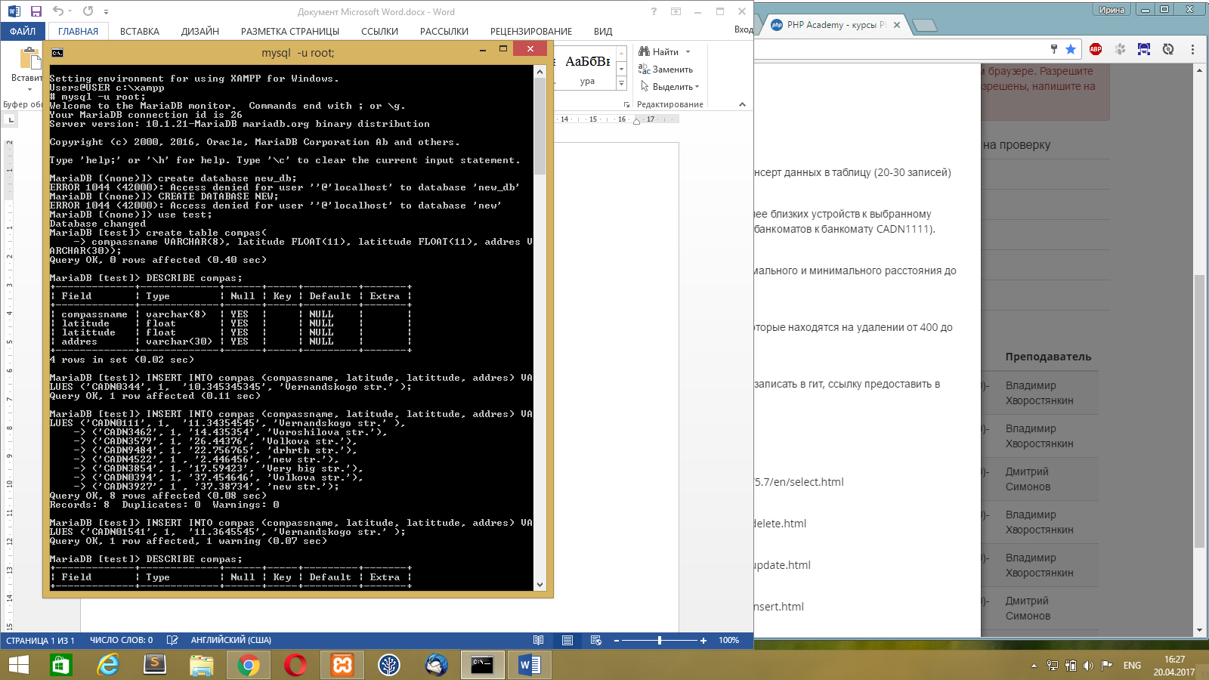

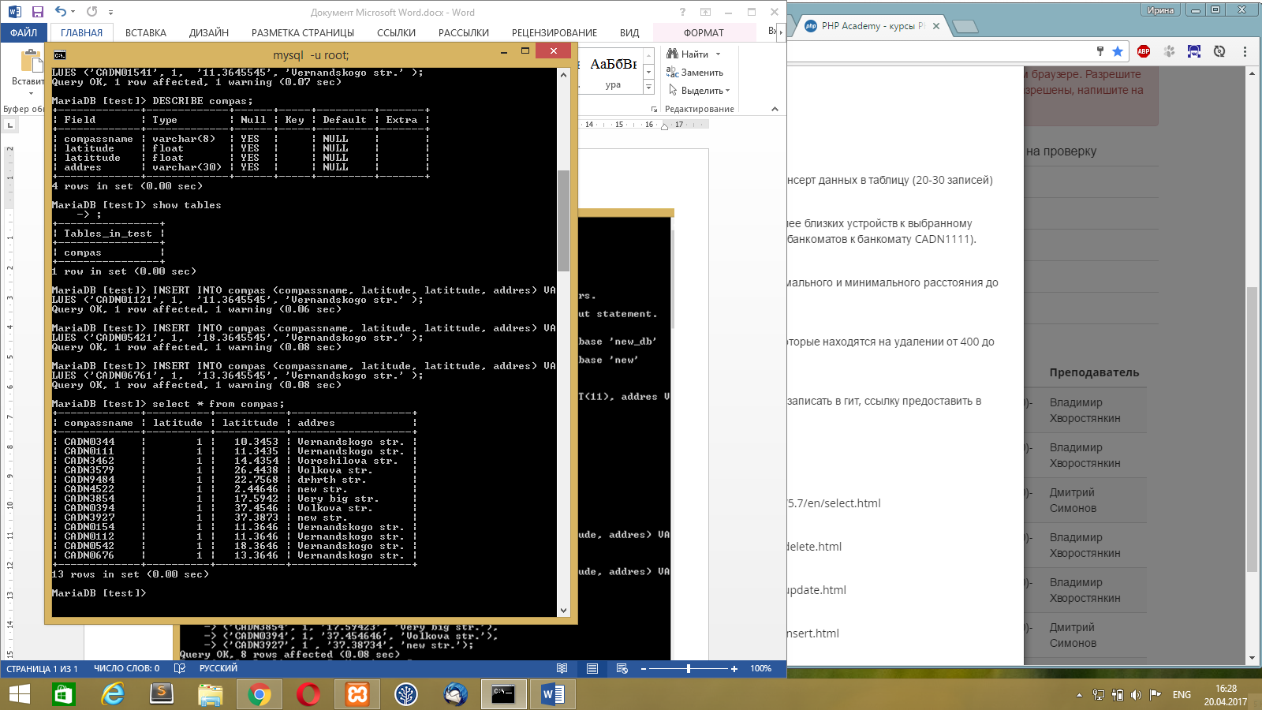

Select \* from compass order by latitude limit 1,6;

SELECT MIN(latittude) as min, MAX(latittude) as max FROM student;

Select \* from compass where latitude between 400/111120 and 1000/111120;